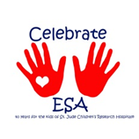

**The Florida Lamp**

**October 2012**

C:\Users\Alisha\Pictures\logo_esa.gif

.

**Music is Magic**

**2012-2013**

**Florida State Board**

**Robin Allred, President**

**Kayla Andux – 1st Vice President**

**Lin King-2nd Vice President**

**Kay Woods- Recording Secretary**

**Rhonda Coy- Corresponding Secretary**

**Jan Humphrey- Treasurer**

**Tina Shafer -Philanthropic Director**

**Barbara Fry-Educational Director**

**Mary Jay Seibert- Jr. Past President/Disaster Fund**

**Sherry Newgent - Parliamentarian**

**Barbara Floyd- Executive Advisor**

**Leslie Boyd- Chaplain**

**Jan Billias- Senior St. Jude Coordinator**

**Roxanne Haynes Jr. St. Jude Coordinator**

**Tarsha Ahmad- Care Connections Coordinator**

**Roxanne Haynes- Credentials Coordinator/PPA Chairman**

**Mary Sosa – Senior Easter Seals Coordinator**

**Robin Krawchuk- Jr. Easter Seals Coordinator**

**Sue Ceriale- Senior Foundation Counselor**

**Margaret Post- Jr. Foundation Counselor**

**Bethany Sutherland- SERC Coordinator**

**Alisha Hulslander- Lamp Editor**

**Janice Dietrich -Audit Chairman**

**Beta Beta Chapter- Awards Chairman**

**Lin King- Webmaster**

PRESIDENT’S MESSAGE

CELEBRATE GOOD TIMES COME ON ….sing it people … That is what we need to do in ESA all year long! I hope you are all still holding Celebrate ESA events this wasn’t just a one-time thing it is continuous. Speaking of celebrating WELCOME OMEGA CHI, Brandon to ESA I know this will be the best decision you have ever made and I am so excited to have you all as a part of our organization! I am having such an amazing time as your FSC President THANK YOU! IC was fantastic! We never stopped from the moment I stepped off the plane until I got back to Tampa. What an honor to carry the Florida Flag for all of our members as well as the balloon for the Celebration of Life honoring our “ESA Angels” ; words cannot express the way it makes me feel, everyone should experience it. I hope all the chapter presidents received my newsletter and shared it with your members. I have had the opportunity to visit a couple of local chapters, and I hope to visit more. If you are holding an event, rush, meeting or whatever, I would love to come and share your excitement and celebration. I know it is impossible for me to get to everyone but rest assured I will do my best. I have said it before and I will say it again … ESA is what YOU make it. By the time you get this the charting of Omega Chi will have been done and Mid-Year will be over - I certainly hope that those who attended are inspired and enthusiastic about sharing ESA, for those who did not attend I am sorry you missed it and hope you plan to attend Leadership in February (yes I said February) or maybe SERC in November. Participating in the fellowship of ESA is what makes us outstanding. Besides SERC conference November holds two other important events. November 6th everyone needs to go to the polls and vote. Women fought and died to win this right for us - we must honor them and our Country by exercising this right. On November 17th all over America we will be doing the Give Thanks Walks for St. Jude. If you haven’t started a team in your area now is the time to do it. If you don’t want to join a team please help raise funds for the ESA members who do have one. Soon the holidays will be upon us and we will all be very busy with family and friends. I would like to take a moment to remind everyone to take time for yourselves as well, and give thanks to all that has been given to you. A friend is someone who knows the song in your heart and can sing it back to you when you have forgotten the words ….to all my friends I wish you peace, blessings and a song in your heart. *Robin*

Table of Contents:

Page 1 – President Robin Allred

Page 2 – Editor’s Page

Pages 3, 4, 5,6,7, – Board Member Articles

Pages 8,9,10,11,12 Chapter Chatter

Insert- Omega Chi Roster

For more pictures and other information see:

[www.esaflorida.net](http://www.esaflorida.net)

**IMPORTANT DATES TO REMEMBER**

**October 1- Delinquent I.C. Council Dues**

**October 6th- Mid Year Board Meeting and Mid Year Meeting – Clearwater FL**

**November 2-3- S.E.R.C Memphis,TN**

**December 10- Deadline for LAMP articles**

**To the Lamp Editors**

**January 1-SERC Dues**

**State $15 - Chapter donation $10.**

**To SERC Treasurer**

**January 14- Audit Lamp Books**

**January 15- Deadline for Jonquil**

**January 12- State Board Meeting 10:00am**

**February 1- Scholarship applications to State Senior Foundation Chair**

**February 1- Deadline for proposed By Law changes to State Parliamentarian**

**February 15- Deadline (postmark) State Officer Nomination Form to State 1st VP**

**February 23- Leadership Board Meeting @ Trinity Community Church Hwy 54 in Wesley Chapel**

●●●

*Note from the Editor,*

*Well we meet again! SO much information! Please do not miss out on the updates! I’d like to personally Welcome Omega Chi to our ESA Family! Ladies this is the beginning of your amazing life in ESA!*

*I can’t wait to see you all at Mid-year! And hopefully S.E.R.C I’M SO EXCITED! much to share!*

*Please take note to the updates for the Yearbooks correct them asap so you don’t forget!*

*The next lamp deadline will be 12/10/12*

*Please have your submissions in on time! See you all soon!*

[*Floridalamp@hotmail.com*](mailto:Floridalamp@hotmail.com)

*Till then ………..*

***Alisha Hulslander***

**YEARBOOK UPDATES**

**Correction for Eta Rho:**

**Dawn Lambert email should be** [**dla327@verizon.net**](mailto:dla327@verizon.net)

**Change for Omega Omega:**

**Tarsha Ahmed has changed her email to** [**tarshacares@gmail.com**](mailto:tarshacares@gmail.com)

**This also needs to be changed in appointed board section for Care Connection Coordinator**

**New Chapter Insert**

**Add the enclosed roster for our new chapter Omega Chi, Brandon to your yearbooks**

***Kayla Andux***

***1st Vice President***

WELCOME Omega Chi!!!! For those of you that were able to attend the chartering ceremony for Omega Chi, Brandon THANK YOU and THANK YOU ALL for your continued support with increasing ESA membership. I want to also send a warm welcome to Amy Holloway with Omega Omega, Largo. Amy is a pledge of the beautiful Margie Post and mother of Jason Holloway the president of our newest and greatest collegiate chapter Delta Chi in Gainesville. I ENCOURAGE you ALL to contact these new members and welcome them to the "family."

WHAT ARE YOU DOING FOR CHOCTOBER?!?!?! I would LOVE to be able to flood IC with all of the great ideas that Florida has to boost membership. Also if you are rushing members in another month that is FANTASTIC please share share share. Remember to keep it light and keep it FUN!!

I hope that everyone has their 1.2.3 in place and ready to use it when you get that question what is ESA?! I cannot stress it enough that the person you are talking to about ESA will learn everything they need to know just by looking into your eyes when you tell them about it. ESA is a GIFT share the sweetness!

I am currently taking applications for the 2013-2014 FSC Board :-) PLEASE run for office!!! Contact me with any questions, concerns, or INTERESTS in ANY position!

\*\* Remember it is impossible to email each member of the FSC so the members of the board are only in contact with their respective chapter officers. If you have not heard anything from your VP in regards to ESA please ask them I have been flooding their in-box, mail box, and any other box they have! I hope that everyone will be sharing their chapter chocolate bar at mid year and also encourage their members to spread the sweetness of ESA to others!

I am looking forward to Mid-Year and know that Beta Beta and the FSC board will "light up my life" as well as yours!

XOXO Kayla

***Lin King***

***Second Vice President***

Hello, Everyone! Summer is over, school has started, we are fast moving toward the Holidays, and all is good with the world! It is interesting how we get caught up in our daily lives and obligations and, now, we have added another dimension to this process – Social Media! We are intrigued and/or addicted to FaceBook, Twitter, LinkedIn, Pinterest, MySpace, Google, and many, many more, not to mention the many e-mails we get on a daily basis! All of these things take time from our busy days and divert our attention.

My challenge to you is to remain focused as much as possible on ESA Florida and our purpose: Helping Others, particularly St. Jude, Florida School for the Deaf and the Blind, Easter Seals, Hope for Heroes and the many local charities we support. One way we can help is to host a state meeting. This is a great way to do fundraising, raise money for your chapter, and renew friendships with your Florida sisters.

Recently, I sent invitations to every chapter requesting meeting bids. To date, I have not heard from anyone, but I know you have been busy with other things in your life such as those mentioned above. Now, we need to focus on Florida ESA. We need to rally together and bid for our state meetings – Mid-Year 2013, Leadership 2014, and State Convention 2014. (As a side bar – this is my installation as State President, so I really want you to bid!!!)

Hosting a state meeting is not that difficult. Mid-Year and Leadership are one-day events – provide space and lunch as well as raffles if you wish, the Board will take care of the rest. If the idea of the raffles scares you, please contact me. I have some alternative ideas to raise money for your chapter and/or donations for your favorite charity. We can work together to make your meeting successful. Another thought is partner with another chapter to host a meeting. This is a fun way to get to know other members. There are myriads of ways to host a meeting and it should be FUN and not be scary!!!

Please contact me because, rest assured, I will be contacting you if I don’t hear from you regarding meeting bids.

***Barbara Fry***

***Educational Director***

“The price of success is hard work, dedication to the job at hand, and the determination that whether we win or lose, we have applied the best of ourselves to the task at hand. -Vince Lombardi

Really looking forward to Mid-Year, sure hope to see you there. We will be highlighting some Educational themes as the books are coming in and I will go over these at Mid-Year. I sent out packets of information to the Chapter President and the Chapter Educational Director and I hope that this helped. There is information for you to use in the state yearbook and on the IC Website www.epsilonsigmaalpha.org. I enjoyed a visit with Gamma Mu when they had a bead party. We made beautiful necklaces and I am very proud of mine, it is the first time I ever tried something like this. It was so nice and I was grateful to be invited. I would love to visit with you and your chapter, please let me know and I will be there. As many of you may already know I have a new phone number and a new e-mail address. Please use the new email from now on as I have moved. My mailing address is still the same. Hopefully you have this information, I sent it to the chapter president and chapter Educational Director and the board.

Barbara J. Fry - P O Box 1094 Titusville, Fl 32781 - 321-607-1988 New email address: [flesaeducational@yahoo.com](mailto:flesaeducational@yahoo.com)

***TinaShafer Philanthropic Director***

Hello Everyone! It is now time to begin our magic and start gearing up for wonderful events to help support State, Local and International Projects to make this year the biggest year in giving for the Florida State Council! The hot days of summer are slowly ending, school is back in session and it is time to focus on raising philanthropic funds.Our newest Chapter in Brandon, Omega Chi, started raising funds with a successful yard sale. Rho Chi and Eta Rho are busy working at the Bucs games. I want to hear what you are doing to Celebrate ESA! Let’s share the ideas via email and Facebook. One idea from IC President Sue Winters is to buy stuffed animals or make prayer shawls for abuse shelters. One easy way to raise funds for one of State Projects – The Florida School for the Deaf and Blind – is to collect Box Tops of Education! They are found on the top of many items you already purchase at the store. Each one is worth 10 cents and they go towards purchases school supplies and computers for schools. Check with your local school, they probably collect them and it can count as a local project.There are some changes this year to the Philanthropic report, please take a moment to review them and contact me with any questions. The changes were made because IC doesn’t need as much detail. I love the fact that the reporting will be easier. As always, I am humbled to serve as the state Philanthropic Director. Please do not hesitate to contact me via email or phone. I will try to answer your questions as best as I can, if I don’t know the answer…then I will get in touch with someone who does!

Together…let’s create some ESA Magic!

***KayWoods  
Recording Secretary***

Summer is already over – how time flies!!! I am looking forward to seeing everyone at Mid Year. Lin sent us an email from Jon Gordon, and I thought it was very thought provoking so will share it with you.

“Be an encourager. Share your gifts and talents. Be original. Be memorable. Show people you care. Be positively contagious. Help others be there best by giving them your best .Make memories.”

Author: Jon Gordon in an article “Who Will Miss You?”

***Mary Jay Seibert***

***Jr. Past President/Disaster Fund***

Is it REALLY fall already? Where has 2012 gone? I hope you are all having some Music in your lives! The Disaster Fund is a truly amazing fund that provides financial help in times of need for our members and their families. We just experienced the wrath of Isaac all along the Gulf coast and I know there are many sisters out there that are probably going to be requesting some help. It is up to us, the membership, to keep this fund available to those that need it. Already this year since I have been the Chair, Florida has had one Sister that requested help and was granted that help. It is with the generous contributions of our members, not only in Florida, but across ALL of the United States, that the Disaster Fund was able to help our sister in need. I am hopeful that you will remember the Disaster Fund when you are developing your Chapter budgets for the year. I would love to have 100% participation from the Florida State Council this year.

If you have any questions about the Disaster Fund and what it can help with, please let me know! By contributing to the Disaster Fund, you can insure that those in need can still have some Music that is Magic in their lives.

***Lin King***

***Webmaster***

The Florida web site is our best asset for information about what’s happening in chapters and recapping our state meetings. It is intended to be a friendly, informational site for all of us. We have sections on St. Jude, Hope for Heroes, Easter Seals, Chapters, Upcoming Events, Special Features, Recipes and much, much more. The Chaplain’s page is essential to support your sisters in their times of joy and distress. I have also included the business card template and address labels. Check it out: [www.esaflorida.net](http://www.esaflorida.net). You don’t want to miss anything exciting. The 2012 – 2013 forms, calendar, and awards have been posted on the Events and Documents page. A lot of these forms have changed so be sure to print and submit the correct form. Please submit information and pictures from your chapter to be included.

As always, if you need help, please contact me – [linjking@aol.com](mailto:linjking@aol.com) or 904-608-9525.

***Angie Wisz***

***Scrapbook***

Hey everyone, I hope everyone is having tons of fun and taking lots of pictures!!! I have created a shutterfly account to make it easier for everyone to get me there pictures, just go to www.shutterfly.com and click sign in. The email address is flesascrapbook@yahoo.com and the password is etarho. If you feel more comfortable mailing me your pictures or anything else that you think would be a great addition to the scrapbook my address is in your yearbook. I look forward to seeing everything that the chapters have been up to!!

***Leslie Boyd***

***Chaplain***  
Hello Sisters! Happy autumn to you! School has begun for some of us and football season is back for all of us! Even though it still feels like summer outside I hope you are enjoying the season! My last article challenged you to find a sister who may need a little extra love from you this year. Have you found one? Has a sister shared some extra love this year with you? If so, please give me or send me your stories in writing before the Mid-year meeting (even if you hand it to me just before the meeting begins!) Of course, if you prefer, no names or chapters have to be mentioned. We have been in constant prayer for Debi Benoit and her family; please participate in this. We all know prayer changes lives! Speaking of changing lives .. new chapters do too! Welcome to ESA Chi Omega! Please send me your prayer requests and praises..we will pray for you across the state and across our nation! My email address is [floydboyd03@aol.com](mailto:floydboyd03@aol.com).

Looking forward to seeing you all at Mid-Year!

***Jan Billias***

***St. Jude Coordinator***

‘Tis the season for Give Thanks Walks, Radio-thons, visits to Memphis to view the SJCRH, and all sorts of thoughts of giving and caring. It’s also the season for wild pig sightings. Florida ESA has taken on a new project. We are now, among many other things, pig farmers. Whether your chapter has chosen to feed one large pig, or an entire family, let’s get started. I have researched this, and learned that our wild pigs like to eat money, and what better way to use that money than to donate it to the St. Jude Children’s Research Hospital? Most of these pigs simply love paper money and checks, and can be much easier manipulated with that type of treat. You can train your pig, and/or show her off at any event. You can actually plan a year-long event for your pig/piglets. Most donors are inspired by stories…stories of a St. Jude Child, your personal stories of ESA, etc. As has been emphasized for many months, now, be prepared to give your stories. St. Jude Children’s

Research Hospital has inspired many a new member. Select a catchy name for your pig. You could use an acronym for your chapter, or other clever name. Who knows? There may be a contest at Leadership for the cutest pig or pig name. You can design your own piggy bank, purchase one, dress it up, or do whatever you think will make her attractive and irresistible. Wild pigs will be squealing all over Florida this year, as they will overtake the State. Florida has never before seen the likes of the wild pigs they will see this year!

****

***Mary Sosa***

***Easter Seals Coordinator***

The summer is coming to a close and we are getting ready for the magic of fall to begin. The kids are back in school and it is time to start working our magic on our many projects. I hope that every chapter will remember to include Easter Seals in their philanthropic projects this year. Robin Krawchuk, Junior Easter Seals Coordinator and I welcome your suggestions or concerns, as always you can reach us at [Flesaeasterseals@yahoo.com](mailto:Flesaeasterseals@yahoo.com) or my personal email [countryangel@wildblue.net](mailto:countryangel@wildblue.net) or by phone 352-546-5347.

*People are often unreasonable and self-centered.*

*Forgive them anyway.*

*If you are kind, people may accuse you of ulterior motives.*

*Be kind anyway.*

*If you are honest, people may cheat you.*

*Be honest anyway.*

*If you find happiness, people may be jealous.*

*Be happy anyway.*

*The good you do today may be forgotten.*

*Do it anyway.*

*Give the world the best you have, and it may never be enough.*

*Give you best anyway.*

*For you see, in the end, it is between you and God.*

*It never was between you and them anyway.*

***Mother Theresa***

This is what we represent in ESA it is not about the awards, the praise, the power; it is about helping each other, together we can do great things! Hope to see y’all at Mid-Year!

***Sue Ceriale***

***Esa Foundation Counselor***

Now is the time to pay your Foundation Dues. Dues are $15.00 for members. New members are always welcome. The first year dues are $25.00 Dues and contributions may now be made online. The contribution form and online contribution page may be found at the website (<http://www.epsilonsigmaalpha.org/about/ESA-Foundation/contribute>).

If you want to mail a check, print the contribution form, fill it out and mail to ESA Headquarters. Changes have come to the scholarship application procedure. All aspects of the application process will now be done online. If you know a student who will be attending college in the fall, encourage them to look at our website: <http://www.epsilonsigmaalpha.org/scholarships-and-grants/scholarships/how-to-apply>) for more information. This process will eliminate applications for being disqualified for missing items necessary for the application by not letting the student proceed until all items are submitted. The online process will also let the student apply for the scholarships they are eligible for and not the ones they think they are eligible for. If you have any questions, please contact me at [flesafoundation@yahoo.com](mailto:flesafoundation@yahoo.com)

***Tarsha Ahmad***

***Care Connection***

Greetings everyone! I pray that you are all well. I want to first inform you that I have a new email just for ESA, it's [tarshacares@gmail.com](mailto:tarshacares@gmail.com) please update in your yearbooks. By the time you read this article we will be approaching the Fall season and saying auspiciously sweet goodbyes to the 2012 hurricane season. Let us not forget all of those who experienced loss or hardship of any kind. From high levels of pollen and mold to disasters including injuries, home damage and even homelessness, the results of a hurricane can cause many stages of disadvantage to anyone it nears. I get emotional just writing this to you. The stories can be overwhelming and heartbreaking. But after you have shed tears, because you must, then diligently pray for them all and lend a helping hand. From the simple act of cleaning out the cupboards, the closets, and even showing up with a mop & broom, to writing a check, getting a group together for a clean up, the list goes on an on. I am sure you get the point. I recently read an article using the word "chesed" when I searched the meaning here's what I discovered, "Loving-Kindness. This is a biblical word,...used in the Psalms (23 times, plus Hosea 2:19) to translate the Hebrew chesed when it refers to God's love for his people Israel.....'mercy,' 'goodness,' and 'great kindness'... used in the Psalms for God's attitude towards man." So with that, let's all go forth in "chesed".

Let this be the year that we do what comes natural, but also let's stretch a bit further and do what is not the "norm" perhaps something a bit difficult to do, but will show someone else just how much ESA really cares. Celebrating ESA is also celebrating how much ESA cares for it's members, the community, and the world! In the words of 2011-12 IC President, Rose Pasillas, " We must make the world aware of what ESA is all about. We must tell our ESA stories and encourage others to become a part". So get involved with a local, state, and/or national charity. From your child's school, to the hospital in our city, to the shelters housing men, women and children of all ages. Tell them your story. When we do are part and lend a helping hand others will want to know our name and get involved too! Make this year and every year after an even better year of caring! May God bless each of you and your efforts.

***Awards***

***Beta Beta Chapter***

Awards Awards There is Magic and Music in Awards! Karen Rennacker and Paula Kelly, aided and abetted by their sisters in Beta Beta are planning secretive, mysterious, magical awards. We had a nice Awards luncheon meeting in June. We have contacted all of the sponsors of the awards to see if they are still going to sponsor their awards. All have said that they would be. Last time we did the Awards the book was one inch thick. When we received it this time it has grown to 2-1/2” so we are culling out the information that is not helpful or useful. Rhonda Coy sent the final copy of the Philanthropic Report form to Paula and Sharon Roberts. They approved the changes which were quite a bit different. The IC reporting has been exceedingly simplified. Therefore Florida State Council along with the 2011-2012 Philanthropic Chairman and the Awards Chairmen have decided to simplify its Philanthropic Report form. A copy of that form is is included in the new Yearbook. Basically, Chapter reports are due (Received) on or before September 30 and must still be received by the Philanthropic Chairman by March 31, 2013. The new form does not request a breakdown of the Local Projects other than for the Florida School for the Deaf and Blind and ESA Foundation Scholarship Fund. There is a separate row/column for reporting the Florida State Projects (Florida School for the Dead and Blind and ESA Foundation Scholarship Fund) Value of Donated Goods and Mileage. There is also a separate area to report hours for the Disaster Fund. The form is clear and easy to understand. These changes will make it

simple for Chapters and the Philanthropic Director for the State to use and implement.

Another new change for Awards: There have been a great number of photographs entered into the Association of the Arts. It has been nearly impossible to compare the beautiful apples with the dimpled oranges so we have changed the thrust of the photography entrants. All photos submitted must have something to do with the theme “MUSIC.” All photography must be framed or mounted for display and must be related to the music theme.

|  |  |
| --- | --- |
| **Photography Theme: Music** | **Photography framed or mounted for display related to music theme** |

We sincerely hope that this information and that these changes make it more inviting to chapters and easier for them to report their philanthropic endeavors and enter photograph into the Association of the Arts.

******

***Did You Know …………………***

1. ***Music Heals***
2. ***Effective therapy for pain***
3. ***Reduces blood pressure***
4. ***Medicine for your heart***
5. ***Speeds post stroke recovery***
6. ***Helps migraines and chronic headaches***
7. ***Boosts immune function***
8. ***Music enhances brain function***
9. ***Reading and literacy skills***
10. ***Spatial temporal reasoning***
11. ***Mathematical abilities***
12. ***Emotional intelligence***
13. ***Improves memory***
14. ***Improves concentration & attention***
15. ***Music improves physical performance***
16. ***Reduces fatigue***
17. ***Increases psychological arousal, improves mood and decreases depression***
18. ***Improves physiological relaxation and reduces stress***
19. ***Improves motor coordination***
20. ***Improves productivity***
21. ***Improves motor coordination***

***To read more go to:***

[***www.emedexpert.com***](http://www.emedexpert.com)

***Surprising effects of music***

***Or*** [***www.livestrong.com***](http://www.livestrong.com)

****

****

**(Music is Magic)**

**C:\Users\Robin\AppData\Local\Microsoft\Windows\Temporary Internet Files\Content.IE5\H08CEJP1\MC900311856[1].wmf**

**CHAPTER**

**CHATTER**

**Alpha Nu-** Alpha Nu is off to a great start after enjoying a relaxing summer. We are hosting a Fall Fashion Show at Coldwater Creek on September 19th to benefit the Florida School for the Deaf and Blind. Our members have been busy selling tickets and getting ready to model Coldwater Creek's beautiful fall line of clothing. We will have many door prizes and finger food available for guests. We expect this fundraiser will be a big success and also lots of fun for our members. Alpha Nu President Barbara Kalm has chosen "Keep the Change..." as her theme this year. Barbara says we don't have to change so that our sorority is no longer recognizable; we just need to keep the changes we want and can use. We want to keep the traditions that keep us different and above being just another club. We want to make changes that will ensure growth in our ESA membership.One of the changes we are working on right now is finding a new, innovative way to support *Hope for Heroes*. We want to find a better way to support the assistance dog program for veterans other than collecting donations in the mall.For our educational program this year we will each tell about our favorite food or beverage. We may just work this into a fundraiser by preparing one of our favorite foods and hosting a dinner. The wheels are turning as we brainstorm about all the wonderful changes we can make and hopefully keep improving upon from year to year.Off and running...

**SIGMA TAU**

Summer is gone!Where?We did enjoy a rush brunch at Rebecca Sutter’s house and good foods and good company; Robin and Kayla joined us and we had a great ESA exchange time. Welcome to Omega Chi, the Bay Area’s newest chapter. Our educational programs are in full swing with our theme of “With a Song in my Heart. “After attending the Carousel play in Tarpon Springs, we enjoyed dinner at Paul’s Seafood House. We got real patriotic with programs with songs on “Over There” from WWI and WWII, “You’re a Grand Old Flag,” and then, “The Star Spangled Banner.” Our local philanthropic projects are in full swing. In July, we donated new and gently-used clothing to Clothes for Kids in Clearwater. A lady seated next to us at the Carousel play in Tarpon Springs became interested in who we were and expressed an interest in coming to our meeting. She also had a trunk load of children’s clothes she was looking to donate somewhere; so, we took those off her hands. We’ve signed up to do Christmas gift wrapping and sell Tree of Love ornaments for Hospice in December at Countryside Mall. Wreaths Across America and patriot gift packages are on our agenda for Hopes for Heroes, along with our usual non-perishable foods and paper products for Religious Community Services. Health wise, we’re doing pretty well this year. Joyce Sabella and Rebecca Sutter both retired this summer. Wonder if they think they’re going to find time to do more things! One of our members, Sandy Stoltzman, returned to Canada to live – we miss her. We hosted Bay Area Council dinner meeting in September with a Chopsticks theme, and we’re ready for Mid-Year in Clearwater

**Epsilon Lambda**

Epsilon Lambda has had their first meeting after a summer of no meetings. Sue and Allan Ceriale attended IC Convention. As a result of convention it was decided to adopt the Santa America Hugs project. Sue will be gathering the materials and schedule a work day to make Hugs. Have you gotten a End of Program Shuttle Bear? We still have them available. For more information contact Laurel Lichtenberger at [SpaceAngel@cfl.rr.com](mailto:SpaceAngel@cfl.rr.com). Congratulations and welcome to the members of Omega Chi. Thank you Kayla for all your hard work also.

 **Gamma Rho**

Donna Dittmer, Jan Waggoner, and Betty Sanders attended the first meeting for the 2012 Give Thanks. Walk Committee in Naples at the Bayfront Inn. The walk will be at Sugden Regional Park.....in Naples…..on November 17, 2012. Will be a 5K around a lake. Nine of our members, Jo Schweinfurth, Dee Ammons, Gladys Bauer, Marilyn Bonneau, Marti Johnson, Charlotte Williams, Donna, Betty, Jan and Jan's guest, Nancy, had lunch at Ford's Garage in downtown Fort Myers. The door handles and faucets in restrooms are from gas pumps, napkins are grease rags and napkin rings are hose clamps. There is an old fashioned car suspended over the bar and one parked out front on the street and various things happening in the establishment cause an oooga horn to blow. Some shopping followed. It was a fun afternoon. Jan and Betty attended the IC Convention in Norman, Oklahoma and participated in the Hope Hop to benefit St. Jude Children's Research Hospital. We had a great time and our State President, Robin, represented Florida very, very well. Jan hosted our August meeting, Donna and Betty presented educational programs on 'Live' and 'Laugh' in keeping with our educational theme, “Live, Laugh, and Love”. We voted to meet at 2:00 PM on the 1st Tuesday of the month beginning in November. We did some bylaw updating, discussed some plans for our Choctober event at our October meeting, vintage jewelry sales, a BUNCO Party and Jan announced that she and Dick are moving back to Texas.......we are not very happy to lose her. Barbara Fly notified us she has had some job changes and being very busy with it all will not be able to participate in ESA at this time. We are going to miss them both. We played Right, Left, Center and Dee was the big winner. Betty hosted our September meeting. Marti presented the program on 'Laughing”. We played Right Left Center and Charlotte was the winner. We also played a practice game of Bunco. We did some work but had fun toooooo!

**Nu Alpha**

As we continue with our chapter theme of “Celebrate ESA”, we had our September meeting on Sept. 11th, where we dressed in patriotic colors. Our educational program, “ESA Celebrates Our Heroes”, brought our guest speaker, a local firefighter, and we each shared where we were on 9/11/01. October’s gathering will be no business, but lots of fun, as we have “Choctober” at the home of Liz Hahn. We plan to invite friends and neighbors and share all sorts of chocolate delights. There will be brochures about St. Jude and ESA and chocolate- related door prizes. Moving into November, Jan Billias will host the business meeting where we will “Fall Back in Time.” Everyone is asked to dress in retro apparel. In August we Celebrated ESA with our annual luncheon at the home of Barbara and John Fry. Once again, they outdid themselves, with baked ham, and all sorts of trim and goodies. We had two administrators from Country Acres Children’s Shelter, who answered our questions and updated us on the facility. We, in turn, presented them with about 25 backpacks filled with school supplies and hygiene items, socks, etc. for their back-to-school needs. We also had two educational programs, “ESA is Changing the World”, and “Celebrate ESA”. It was a great day.We will be having a garage sale, and other fundraisers, as well as our constant support of community projects, such as Relay for Life, Turtle Crawl, Give Thanks Walk, and Beach Clean Ups. We continue to pray for and support our Debi Benoit, as she battles this terrible infection since back in the Spring. By the time you read this, it is our prayer she will be strong enough to attend some of our functions. Closing on a happy note, Jan Hall is expecting another grandchild in November. This would be the great-grandchild of Barbara Dyal. Wishing you all blessings at Christmas. Celebrate ESA all year long!

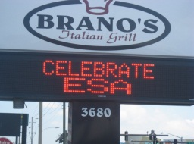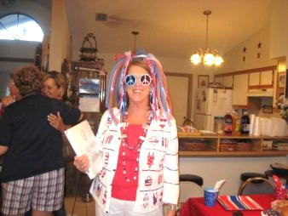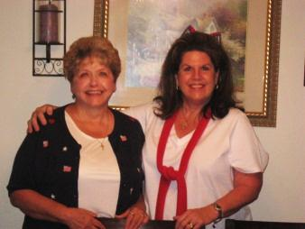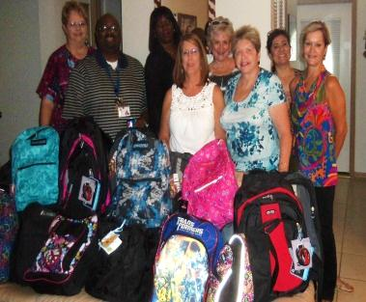

**Alpha Rho**

Cyndi Lauper sang it “Girls Just Want To Have Fun” and Alpha Rho’s President, Beth McCoy, has chosen it as her theme this year. Chapter sisters are excited about all of the fun socials she has planned for them this year. In July we scored a lot of spares and even a few strikes during our bowling outing and in August a fun evening was had by all playing Crazy Bridge at Julie and Jerry Lentz house. Gary was the big winner of the evening! Our educational reports are following the same theme. Chapter sisters base their educational program on something they think is fun.Gail shared her passion of working puzzles, Lorraine taught us how to knit, Jan and Ruth shared their love of “zip lining” and Beth taught us all about locating and collecting vintage jewelry.Thanks to our awesome Philanthropic Chairman, Sandee Rini, our chapter is staying busy with several projects this year. We prepared food for the Ronald McDonald House, we are currently working at Sam’s Club raising money for St Judes and are feverishly working on our individual crafts for the annual Craft Fair held the first weekend in December at Lake Park where we have a booth to sell our masterpieces! We also collected school supplies for Quail Hollow Elementary where AR sister Jan Humphrey is a teacher.We are looking forward to attending the chartering of ESA’s newest chapter sponsored by Eta Rho and look forward to seeing our Bay Area Council sisters in September with our own, Susan Stotts chairing the Bay Area meeting. After all, girls just want to have fun! But we also have fun by helping others.

**Beta Beta**.

Whew! And Whew again. And throw in some holy smokes and golly gees. Where the ?!\*^& did summer go? We are back in the swing of things after a resounding couple of meetings after our two month sabbatical. (Actually I am making it up about our resounding meetings because we haven’t met yet before this tale was written.) Anyway, some of us went to Beau Rivage in Biloxi. It was a ten hour bus trip up and back. We were able to tour the town before Isaac nearly wiped it out again. It missed though. Evidently the day the Hard Rock Casino was due to open was the day Katrina hit. It then took two years for the Casino to repair itself. Isaac hit the same day 7 years later. I think Tampa area is a better place for us, don’t you? Anyway, we had a great time discovering the delights that Biloxi had. Las Vegas it isn’t though. Leah Hoke, Karen Rennacker and Paula Kelly with significant others took the Biloxi tour. We have signed up to attend a Murder Mystery Dinner and await that with bated breath. Karen Rennacker is a super sleuth. She is normally the first one to decipher the clues. We met and ate at the Greek Towne Grille to make sure it is perfect for our upcoming hostessing of Mid-Year. It is. You will be pleased. It is not easy to find a gem like this anywhere. Peggy Redmond fell on her first day of her Spain cruise and hurt her leg so badly she had to be in a wheelchair for 6 weeks. She is now mended and well. Lynn Bond—oh my gosh. She fell and broke her wrist. Then she had more incidents, and is finally able to drive and is also on her way to being mended. Peggy D. had an incident with her new car that has truly been a nightmare. It put a big dent in their travel plans. Paula Kelly helped out with the Republican Convention in Tampa and worked at a primary election polling place as an Assistant Clerk. Janice Harmon ran off to Texas for a wedding for a week, Sharon R. is in her new home and loving it. Irene Gahan has been having a few medical issues, but hosted all of us at her home in spite of them. Susan Gahan has been working hard on her estate sales business and even held one in Michigan. Sandy Edwards is working hard on her new job. Eleanor Eichelberger went to another class reunion in Pennsylvania. Some of us went to Savannah for 2 nights and 3 days and managed to get into Paula Dean’s restaurant. That alone is a giant coup (coo?). Whatever. Judy Gauron continues to devote hours and hours to Hospice and enjoys it immensely. After her awesome attendance at the Board meeting, Sharon Kalinowski has managed to make herself scarce. Our theme is “We are family.” And here we are: Nuff said.

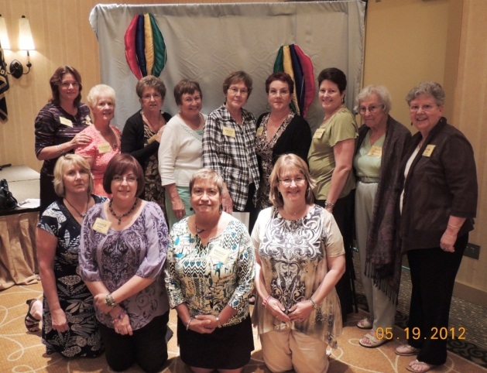

**Lambda Xi**

What an amazing year we have had so far! Our President, Regina Bell, compiled the interests of each sister and presented three main goals to accomplish this year:1) Concentrate resources (time and money) to support St. Jude events and activities. 2) Support our community by focusing on the indigent population. 3) Strengthen the foundation of the chapter through involvement and education of ESA.With each of these goals we hope to help our community as well as strengthen our bond as sisters and ESA members. We plan to make beautiful music this year by spreading our wings and flying through with Regina’s theme: “Dance Like the Butterfly.” Our chapter is planning to send a group of ladies to SERC this year in Memphis, TN. We are also hosting a Pancake Breakfast on October 13th from 8-10 AM to help promote the St. Jude Give thanks. Walk. There will be an informational session about the Walk as well as pancakes for a minimum donation of $5! We will have raffle baskets as well. Please come out to help support St. Jude and Lambda Xi! We have been involved in a plethora of fun events already this year. We have participated in the following: Hubbard House Volunteer Orientation & various related trainings, provided personal care bags & school supplies to Hubbard House (Duval County’s safe house for abused women and children), and attended St. Jude Give thanks. Walk informational meetings. We’ve also enjoyed each other’s company at a Lia Sophia jewelry party in July and a wine tasting social in August. We’re looking forward to more fun and fellowship at our RUSH Tea Party on September 29th at 10am. Our Educational Theme this year is: “My Other Little Black Dress,” where we will learn about the male counterparts who make an impact in our lives. It will coincide with the President’s theme to remind us to get up and move…for if we do not move, we cannot dance. These people are like butterflies in that they help us fly through the stages in our life! So far, Jasmin Guevara has presented on her father, and it was an emotional story about how important he is in her life!We also have a new website for our Chapter: www.esa-lambdaxi.webs.com. Please visit our site to learn more about us and to check out all that Lambda Xi is doing in the Jacksonville area. Since we are hosting State Convention in May 2013, we hope that you will follow the music all the way to Jacksonville!We look forward to seeing you in October for Mid-Year! May the music flow and the laughter fill the room!

**Eta Rho**

Eta Rho has kept the momentum going this month. We had a PJ Social at Kayla’s home. We had our very own Janice give us facials, mini pedicures and manicures. It was a great time for us to unwind and enjoy each other’s company. Eta Rho has been representing ESA with pride while working the beer tents at the Bucs games these past 4 weeks. It’s a great time and we get to tell everyone about ESA while doing it. On September 8th several members of Eta Rho and Rho Chi volunteered at the 2012 FARA Energy Ball. It was an incredible evening. We worked the registration desk, helped people with Bid Pal machines, explained the auction items and were cheerleaders for the highest bidders during the Silent Auction! One of the auction items went for $22,000.00. Now that’s something to cheer about. This event rose over $1.5 Million dollars for FARA. We look forward to doing it again next year. We will be chartering our newest charter, Omega Chi , Saturday September 15th in Brandon. We are so excited and can’t wait to cheer them on! They are going to do great things, we know it. All of us are looking forward to Mid-Year in a few weeks, fun times with some fun ladies. Eta Rho will be there in full force☺ We will be also be helping out at the 2nd Annual BINGO! For a Cure on October 10th at the Lansbrook Golf Club. Everyone is welcome. All proceeds will go to FARA. We are SUPER excited to be part of the Give Thanks Walk on November17, 2012 at Al Lopez Park in Tampa! As always, we will continue to look for new ways to make a difference in our community. We are looking forward to all the fun Fall events coming up and how we can spread the ESA word!

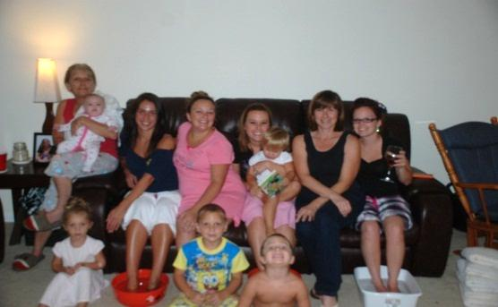

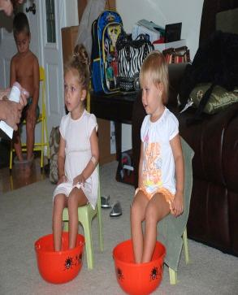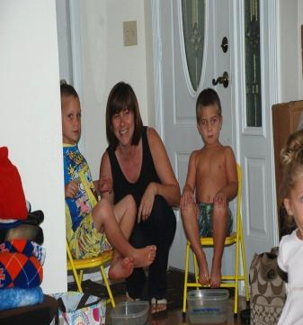

A little pampering in order … for Eta Rho

[Type a quote from the document or the summary of an interesting point. You can position the text box anywhere in the document. Use the Drawing Tools tab to change the formatting of the pull quote text box.]

**Rho Chi**

Our year is progressing smoothly with great philanthropic projects and fellowship with President Orma leading the way with our theme “Health and Fitness”. We have donated over 59lbs of food to our local food banks as we continue our campaign for “Pounds for Pounds”… The football season has begun and so we find ourselves back to Raymond James Stadium raising money for International, State and local charities. (GO BUCS. We recently joined many other volunteers and sisters supporting FARA at the Energy Ball at the Ala Carte Pavilion in Tampa, an extremely rewarding evening. We are gearing up for the Giving Thanks Walk on November 17th at Al Lopez Park in Tampa. Please join us by forming a team to support the children of St. Jude. Our social committee has been hard at work planning and setting dates for our yearly socials. We had a beach day with all our families in attendance and followed up with an afternoon of bowling..I must say we are much better at laying on the beach than throwing a bowling ball..Many of our members were fortunate enough to be able to attend the Chartering of our newest chapter Omega Chi in Brandon on Sept 15th. What an honor to welcome 5 new sisters into our lives. Thank You Omega Chi for the honor.Busy…..Busy…. Busy…….the best way to be……

Looking forward to seeing all of you at Mid Year October 6th. Until later Rho Chi wishes you all a beautiful fall, an even cooler winter and prosperous Holiday Season.

**Omega Chi**

Hello, from Omega Chi in Brandon Florida!! We are so excited to be a part of ESA and all the wonderful things that are happening! We have been working behind the scenes for the last few months getting all the details put together for the new Brandon chapter. We are now up and prepared to make MUSIC MAGIC with Florida and all the amazing people we are going to come in contact with, in and through ESA. Our Chapter is currently chartered with 6 ladies and we have a growing list of others that we are itching to share ESA with. At this time, we are stirring up a few ideas for charity events and are looking forward to all the lives that we are going to touch! Being the newbies around, we are very eager to get our brains working to make the ESA ways show not only in our area but everywhere we go! We look forward to getting to know our second family in ESA and making a difference in our actions. Also, we would like to send a **HUGE** thank you to Eta Rho for all their love and support, without a simple question from Mrs. Kayla Andux we would have never gotten this far… You never know what can happen, unless you ask!! Plain and simple! Here is to our New Beginnings in ESA!

Presidents of :

Alpha Rho, Rho Chi, Eta Rho, Omega Chi

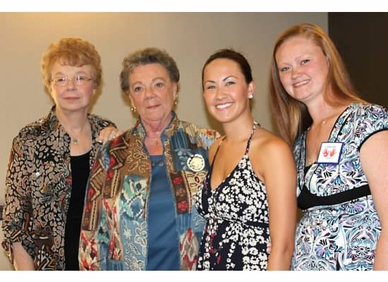

\*This is how we got started\*

**WELCOME OMEGA CHI**

OmegaChi Chapter 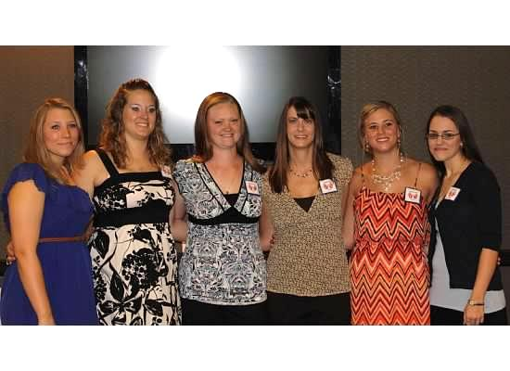

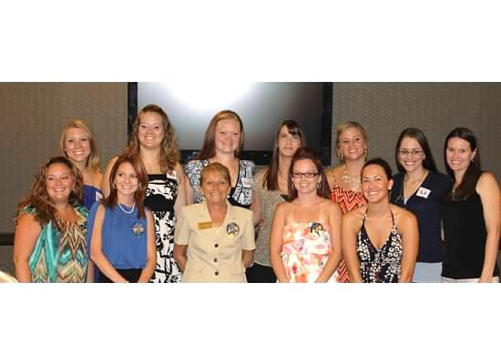 **“New Beginning’s” Omega Chi Chapter**

Omega Chi and Eta Rho

